Clinical Information Pack
Clinical Lecturer

Post title: | NIHR Clinical Lecturer in Anaesthesia
School: | Clinical and Experimental Sciences
Faculty: | Faculty of Medicine (FoM)
Career Pathway: | Clinical | Level: | *AMNL or CADT
Salary: AMNL scale | £39,260 | To | £68,478
Salary: CADT scale | £55,329 (ST3/CT3 to ST5) | To | £63,152 (ST6 to ST8)
Associated NHS bodies | University Hospital Southampton NHS Foundation Trust (UHS)
Clinical category: | Balanced portfolio
Posts responsible to: | Head of School
Posts responsible for: | Research Staff and Postgraduate Research Students as appropriate

*AMNL scale to be used if candidate at or above ST3 on 3 August 2016

CADT scale to be used if candidate below ST3 on 3 August 2016

Particulars of Appointment

The Faculty of Medicine wishes to appoint an NIHR Academic Clinical Lecturer, hosted by one of the following clinical specialties, Anaesthesia, Primary Care or Public Health.

The post is intended for an applicant within any of these three specialties, with the specialty of the final (single) post dependent on the successful applicant.

The applicant will have a higher research degree (or have submitted for such a degree) and appropriate research experience.

This pack sets out the details for the post as it would be linked to Anaesthesia, should this be the specialty of the successful applicant.

The post-holder will be pursuing their development of research and teaching within the School of Clinical & Experimental Sciences in the Faculty of Medicine, University of Southampton.

In this post-doctoral role, the successful candidate will be in specialist clinical training in Anaesthesia at ST3 level or above and have substantial experience of the relevant research areas, a proven track record of high-quality original research publications, the ability to work well in a multidisciplinary, multi-professional team and hold a corresponding NTN.

The post-holder will also have clinical commitments at University Hospital Southampton NHS Foundation Trust that will lead to the acquisition of clinical skills required for full registration within the specialty.

The post is subject to terms and conditions of service determined by the University of Southampton and in its honorary clinical capacity by the University Hospital Southampton Foundation Trust Board.

The University of Southampton

The University of Southampton is a leading research-intensive University, a member of the Russell Group and one of the top 100 universities worldwide. We deliver an excellent educational experience, world-leading research and we are known for successfully commercialising that research through enterprise.

This is an exciting time to join the University of Southampton. We have an aspirational University Strategy (see www.southampton.ac.uk/strategy), setting out our ambitions over the next five years. The strategy involves achieving a top 10 place in the UK for research, which we will achieve by investing in the highest quality staff and facilities. We are also transforming the education offer available to undergraduate and postgraduate students across the University, providing greater flexibility and modular courses, with a strong international focus.

The Faculty of Medicine

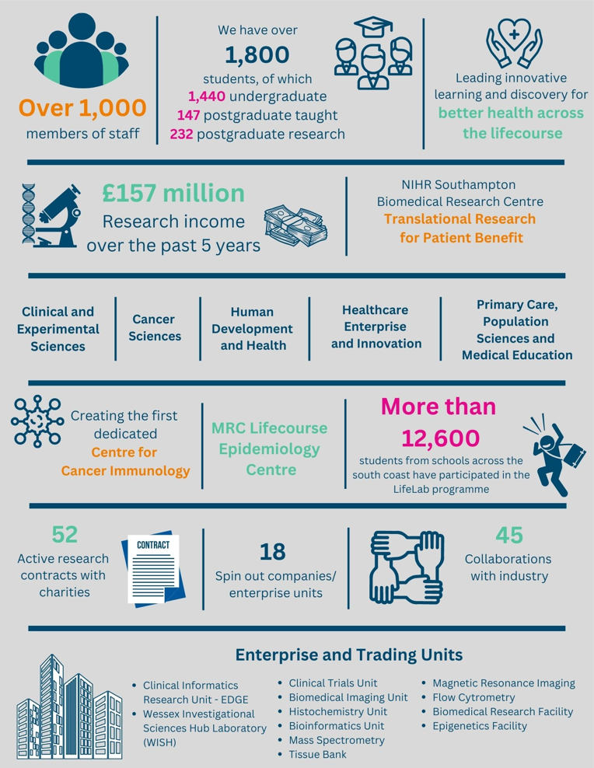

The creation of the Faculty of Medicine has enabled us to build upon strong foundations of basic research and clinical translation. Working with colleagues across the University and in the local NHS we have strengthened our position as a renowned centre for translational research, leading innovative learning and discovery for better health across the life-course. In this context, we are looking to appoint an outstanding clinical academic to develop and lead a major programme of funded clinical research in the field of respiratory medicine.

Key to the success of the Faculty of Medicine is the delivery of high-quality education for undergraduate and postgraduate students, building on our partnership in biomedical research with University Hospital Southampton NHS Foundation Trust and fostering new collaborations with the physical sciences, including computing and bioengineering. The new appointment in respiratory medicine will play a key role in these developments.

The Faculty celebrated its 40th anniversary in 2016. In 1971 FoM consisted of 40 students. FoM is now reputed for its excellence in research, innovative clinical teaching and is a vibrant pillar of the South of England community.

The Student Experience

We offer a range of undergraduate programmes: the BM4 programme, a graduate-entry four-year programme which accepts 48 students per year; and the BM5 and BMedSc programme which accepts 200 students per year including approximately 30 students from a BM6 programme aimed at widening access to a medical career. Students also join the first two years for teaching in Southampton on the BM(EU) Programme, an affiliation with a German Medical school in Kassel. Biomedical/ Psychosocial Teaching in the first two years of the BM programmes is delivered in the South Block of Southampton General Hospital as well as on Highfield campus. Clinical teaching takes place at Southampton General Hospital and the adjoining Princess Anne Hospital, the Royal South Hants Hospital, and in NHS Trusts and General Practices throughout Hampshire, Dorset, West Sussex and Salisbury.

The BM5 programme has a number of distinctive features. These include the integrated nature of teaching where the scientific disciplines are taught together in a clinical context using a systems-based approach and the BMedSc programme, a four-month supervised research project undertaken in Year 3. There is also the opportunity, for selected students, to undertake an integrated, intercalated Masters in Medical Science (MMedSc). The BM4 programme also has several key features. These include clinical topics in the first two years where students meet on a regular basis in Graduate Groups and learning with BM5 students in the third and fourth years on all clinical attachments. All students take the same final examinations. All programmes have substantial clinical experience in the first two years, student selected components, dispersed final year attachments, work shadowing prior to commencing a Foundation post and inter-professional learning.

In addition to the undergraduate BM programmes the School provides four Masters Degree programmes in Public Health, Allergy, Genomics and Diabetes plus an MRres.

Research and Enterprise

The Faculty of Medicine has a clear research strategy to investigate the biomedical basis of common human diseases and to translate this into clinical practice. All research undertaken within the Faculty has clear evidence of international excellence and is delivered through appropriate Faculty Schools.

The Faculty of Medicine Enterprise Strategy is fully aligned to the University Enterprise Strategy to provide a step change to its enterprise and innovation culture, delivering global outreach, community engagement, innovative healthcare and policy. We work with all stakeholders from industry and pharma to health providers and the community.

Equality, Diversity and Inclusivity

We are committed to positively advancing equality of opportunity. We participate in a number of equality initiatives which celebrate good employment practice for the advancement of diversity, equality and inclusivity. These include the Stonewall Workplace Equality Index, the Race Equality Charter and Athena Swan, (for which we are currently silver award holders). We also have a number of staff equality committees who champion the advancement of equalities for diverse groups.

Southampton Behaviours

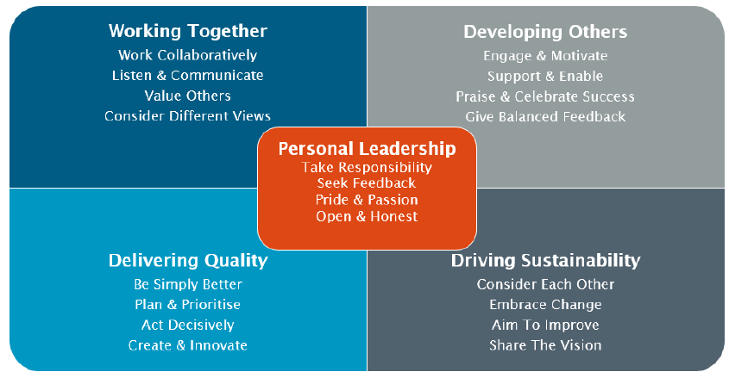

Post information

Programme Lead: Professor Mike Grocott

Our group has particular strengths in resuscitation, lung injury, hypoxia, perioperative medicine, fluid therapy, applied human physiology of exercise, rehabilitation and health services research and welcomes applications from individuals with complementary research interests. We work in the Perioperative and Critical Care theme within the NIHR Southampton Biomedical Research Centre, one of only two such themes in the UK.

CLs can join funded programmes including:
- Perioperative Health Services Research
- Perioperative care and prehabilitation
- Oxygen therapy in perioperative and critical care
- Fluid therapy in perioperative and critical care
Clinical training would be undertaken as part of the Department of Anaesthesia at University Hospital Southampton.

University Hospital Southampton NHS Foundation Trust (UHS)

University Hospital Southampton NHS Foundation Trust provides services to some 1.9 million people living in Southampton and south Hampshire, plus specialist services such as neurosciences, cardiac services and children's intensive care to more than 3.7 million people in central southern England and the Channel Islands.
The Trust is also a major centre for teaching and research in association with the University of Southampton and partners including the Medical Research Council and Wellcome Trust.
UHS gained Foundation Trust status on 1 October 2011.
Every year 11,500 UHS staff:
- treat around 150,000 inpatients and day patients, including about 50,000 emergency admissions;
- see over 624,000 people at outpatient appointments; and
- deal with around 135,000 cases in the emergency department.
Providing these services costs £1.9 million a day.

Job Description and Person Specification

Job purpose
To undertake research in accordance with specific research projects under supervision as above (0.5fte); and to undertake clinical duties as a Specialist Registrar (0.5fte)

Key Research accountabilities |  | % Time
 | To develop and carry out an area of personal research.  To disseminate findings in peer-reviewed journals, present results at conferences or exhibit work at appropriate events.  To contribute to the writing of bids for research funding.  Carry out administrative tasks associated with specified research funding, for example applications for relevant approvals, risk assessment of research activities, organisation of project meetings and documentation. Implementation of procedures required to ensure accurate and timely formal reporting and financial control. | 35% or more
 | Key Education accountabilities
 | As a member of a teaching team within an established programme of study, support the teaching objectives of the School/Department by delivering teaching to students at undergraduate and/or postgraduate level, through allocated lectures, tutorials, practicals and seminars.  Directly supervise students, providing advice on study skills and helping with learning problems. Identify the learning needs of students and define learning objectives. Set and mark coursework and exams, providing constructive feedback to students.  Develop own teaching materials, methods and approaches, with guidance. Obtain and analyse feedback on own teaching design and delivery to facilitate this.  Continually update own knowledge and understanding of subject area, incorporating knowledge of advances into own teaching contributions. | 10%

 | Key Management, Leadership and Engagement accountabilities
 | Contribute to the efficient management and administration of the research group and School/Department by performing personal administrative duties as allocated by the Head, e.g. library representative, year tutor, exchange-programme coordinator, etc. | 5%
Key Clinical accountabilities |  | % Time
Clinical academic staff are managerially accountable for their clinical duties to the designated Clinical Lead for the relevant specialty within University Hospital Southampton NHS Foundation Trust (and successor organisations).  On-call Arrangements  The exact nature of any on-call commitments to be undertaken will be agreed within the job plan. |  | Up to 50%

Internal and External Relationships
Direct responsibility to programme leads.
May have additional reporting and liaison responsibilities to external funding bodies or sponsors.
Collaborators/colleagues in other work areas and institutions.

Staff Benefits
Working at the University of Southampton gives you access to a wide range of benefits in addition to our competitive rates of pay. Our core benefits include pension scheme membership; a generous annual leave allowance (supplemented by University closure days and public holidays) and excellent family leave arrangements (including maternity, paternity, adoption and parental leave).

- Faculty Mentoring Scheme;
- Ability to remain in NHS pension scheme, subject to qualifying criteria;
- Discounted Sport and Wellbeing membership;
- Access to private dental and/or healthcare insurance;
- Cycle to work scheme
- Tax-Free childcare

Person Specification

Criteria | Essential | Desirable | How to be assessed
Qualifications, knowledge and experience | Medical degree  GMC registration  FRCA or equivalent  In speciality clinical training and appointable to NTN or hold NTN already  In specialist training in Anaesthesia at ST3 level or above.  Evidence of commitment to a clinical academic career  Evidence of ability to undertake statistical analysis  PhD/MD (or equivalent) in a research area relevant to the post. The applicant must have submitted their PhD or MD thesis at the time of application, and the higher research degree must be awarded before commencing post.  Experience of undergraduate/postgraduate medical teaching | Experience in relevant specialist training  First author publication in international peer-reviewed manuscript | CV/interview
Planning and organising | Ability to organise own research activities to deadlines and standards |  | CV/Interview
Problem solving and initiative | Ability to develop understanding of complex problems and apply in-depth knowledge to address them |  | CV/interview
Management and teamwork | Work effectively in a team, understanding strengths and weaknesses of others | Ability to work in a multi-professional team | CV/interview
Communicating and influencing | Communicating new and complex information effectively, both verbally and in writing, engaging the interest and enthusiasm of the target audience  Ability to present research results at group meetings and conferences  Track record of original publications in leading peer-reviewed journals  Work proactively with colleagues in other work areas/institutions, contributing specialist knowledge to achieve outcomes | National/ international research award(s)  Oral presentations at international meetings | CV/interview
Other skills and behaviours | Positive attitude to colleagues and students. |  | CV/interview
Special requirements | Able to attend national and international conferences to present research results | Experience of presenting at national and international conferences | CV/interview

JOB HAZARD ANALYSIS

Is this an office-based post?
☐ Yes | If this post is an office-based job with routine office hazards (eg: use of VDU), no further information needs to be supplied. Do not complete the section below.
☒ No | If this post is not office-based or has some hazards other than routine office (eg: more than use of VDU) please complete the analysis below.  Hiring managers are asked to complete this section as accurately as possible to ensure the safety of the post-holder.

## - HR will send a full PEHQ to all applicants for this position. Please note, if full health clearance is required for a role, this will apply to all individuals, including existing members of staff.

ENVIRONMENTAL EXPOSURES | Occasionally  (<30% of time) | Frequently  (30-60% of time) | Constantly  (> 60% of time)
Outside work
Extremes of temperature (eg: fridge/ furnace)
## Potential for exposure to body fluids
## Noise (greater than 80 dba - 8 hrs twa)
## Exposure to hazardous substances (eg: solvents, liquids, dust, fumes, biohazards). Specify below:
Frequent hand washing
Ionising radiation
EQUIPMENT/TOOLS/MACHINES USED
## Food handling
## Driving university vehicles(eg: car/van/LGV/PCV)
## Use of latex gloves (prohibited unless specific clinical necessity)
## Vibrating tools (eg: strimmers, hammer drill, lawnmowers)
PHYSICAL ABILITIES
Load manual handling
Repetitive crouching/kneeling/stooping
Repetitive pulling/pushing
Repetitive lifting
Standing for prolonged periods
Repetitive climbing (ie: steps, stools, ladders, stairs)
Fine motor grips (eg: pipetting)
Gross motor grips
Repetitive reaching below shoulder height
Repetitive reaching at shoulder height
Repetitive reaching above shoulder height
PSYCHOSOCIAL ISSUES
Face to face contact with public
Lone working
## Shift work/night work/on call duties

